Board of Directors
Mr. Nicholas Eftimiades
Founder, Chairman

Mr. Paul Graziani
CEO, Analytical Graphics, Inc.
Vice Chairman

Mr. Stephen S. Oswald
Syzygy Enterprises
Former Astronaut

Ms. Catherine Steele
VP, The Aerospace Corporation

Dr. Patrick J. Ford
Director
Spaceport Northwest

Brig Gen James Haywood, United States Air Force (Ret.)

Mr. Lon Rains
Dir, Communications NGC

Mr. Joshua T. Hartman
Managing Partner
Renaissance Strategic Advisors

Mr. Earl Madison
Lockheed Martin

Advisory Board Members

Hon. Dana Rohrabacher
United States Representative

Dr. Buzz Aldrin
President, Share Space Foundation
Apollo 11 astronaut

Maj Gen Howard J. Mitchell, United States Air Force (Ret.)

Mr. David Logsdon
Dir, Space Enterprise Council

Dr. Louis Friedman
Co-founder, The Planetary Society

Mr. Bill Nye
Executive Director, The Planetary Society

Mr. Pat Rawlings
Space Artist and Animator

Mr. Bill Prady
Co-Creator, Producer
CBS’s The Big Bang Theory

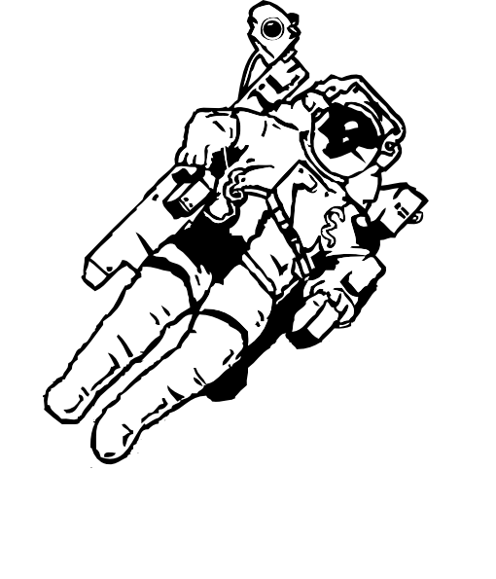

Dear Community Supporter,

The Federation of Galaxy Explorers delivers Space-based STEM education to help guide our next generation of scientists and engineers– but we cannot do this without your help. We ask you to please consider donating a gift certificate, product, or service to this year’s Galaxy Ball Silent Auction. Your generosity will be seen by thousands of people through our website, event program, newsletter, and public announcements.

The Galaxy Ball is our sole fundraising event, and hosts over 200 aerospace and government members at the Hyatt Regency in Crystal City. This year’s gala is scheduled for Thursday, June 15, 2017. All proceeds help the organization educate, guide, and impassion the next generation to accept the challenge of expanding humanity’s presence in space.

Galaxy Explorers is a 501(c)3 non-profit educational organization. Our volunteers teach and inspire children in science and engineering using the theme of space exploration. In fourteen years this all-volunteer organization hosted space camps, after school programs, and special events children in Virginia, Maryland, Washington, DC, Colorado, Pennsylvania, Oregon, Montana, New Mexico, Texas, and New Jersey. Our summer camps, Moon Base and Mars Base One, are wonderful experiences for kids, parents, and educators.

Supporters like you help us continue to galvanize our youth in space related science and engineering.

Please return the attached donation form along with your contribution by May 24, 2017. If you cannot mail your donation, please contact us at stephe@foge.org or 703.261.9834 and we will arrange for pickup. You are welcome to enclose brochures, business cards and promotional items, and we will be happy to display them along with your donation at the Galaxy Ball.

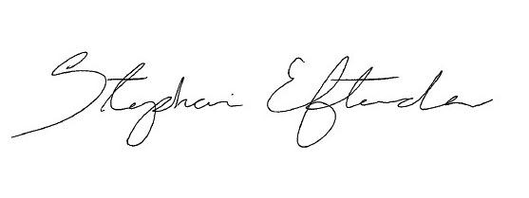
Your donation is fully tax deductible as allowed by law (FEIN: 52-2347666). We are happy to reflect your generosity on our website, gala program, gala signage, and on our Facebook and Twitter pages. Thank you again for your generous support; we are sincerely grateful. Together we can make a significant difference in the future of children across the nation.

Sincerely,

Stephanie Eftimiades
Director of Events
StephE@foge.org (c)703.261.9834

